**Guided Capstone Report**

Big Mountain is a premiere resort and has recently spent more money on infrastructure. It wants to find ways to reduce costs and maximize revenue by focusing on investments that lead to maximum ticket pricing.

**Analysis**

We explored if closing down runs would reduce cost but found it would not make a significant difference.

We explored what factors go into consumers paying higher prices for tickets. We found that 4 main factors lift count/speed, total runs, vertical drop and snow making ability are what consumers are willing to pay more for.

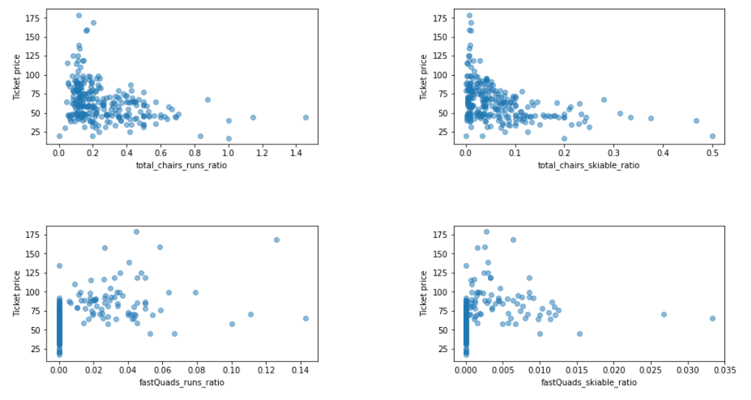

Currently Big Mountain Charges $81 which is above average. Big Mountain has lots of vertical drop and long runs coupled with fast quads and a large skiable area. Overall it is a very desirable resort on these metrics.

Our model suggests an expected ticket price of around 95$ can be supported with Big Mountains current offerings.

Shutting down least used runs doesn't help reduce costs and instead eats into overall revenue faster. Data does support that adding a chair lift can justify higher ticket prices(about +$2 on average).

**Recommendations**

Based on this analysis Big mountain should raise ticket prices because of its desirable features.

It should also continue to invest in fast chair lifts and work on increasing its run count and snow making ability.